**Indian Ocean**

5* Mauritius From £1,089 pp 4* Sri Lanka From £799 pp

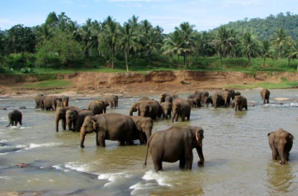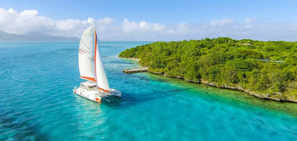

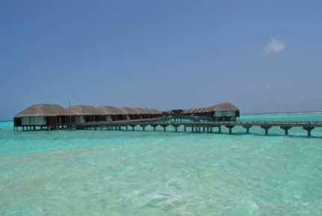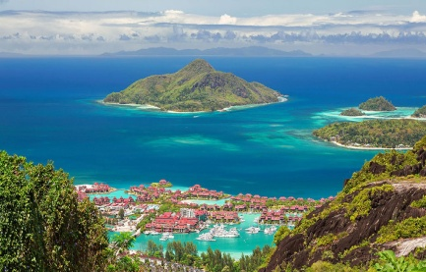4* Seychelles From £1,529 pp 5* Maldives From £2,749 pp